**MEETING MINUTES: SUMO DIGITAL GROUP PROJECT**

Date of Meeting :13/March/2019

Time of Meeting :12:00

Attendees: Joe, Kacey, Andreea, Tomas

**Post-mortem of previous week**

What went well:

* All tasks on Jira completed before deadline and at a good standard
* Communication – everyone was informed and was given more detail about tasks if needed via email or Discord, no issues to be reported
* Main 3D asset development finished
* Traps included in the game, yet not fully functional
* Rat movement done (targets move in simple patterns)

What went badly:

* Feedback from the presentation was not included in the last set of minutes. They will be included in this file.
* Bug encountered in the character movement

Feedback Recieved :

* 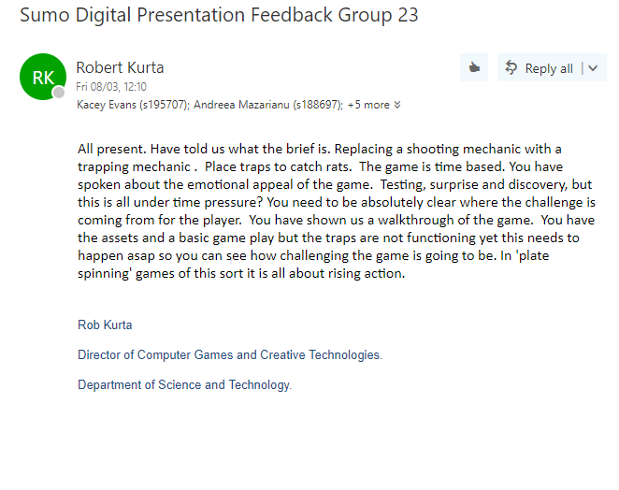Feedback about minutes uploaded on Github. Presentation feedback was not included in the last minutes’ document

Based on the feedback received, we are currently trying to speed up the process of including the functional traps into the game. Traps currently are a hitbox trigger, the interactions for traps and ‘bait’ items / rats are not yet functional, but should be achieved by our next jam session.

In terms of controlling the wanted emotions, we need to playtest the game first in order to iterate on it. Playtesting should be possible by week 9.

Individual work completed:

Joe- all task completed  
Kacey- all tasks completed  
Tomas- all tasks completed  
Andreea- all tasks completed

**Overall Aim of the current weeks’ sprint**

Tasks for the current week:

Design

As the 3D asset development is finished (all key elements for the game have been delivered), we are concentrating on developing intuitive sprites for the UI and visual feedback. Main menu would be created during this sprint, a written version of the instruction would be developed (so it could be accessed via Main Menu). The main focus for this sprint is importing all of the assets and sprites created until this point into the level and concentrate on item placement.

Programming

The focus of this weeks programming tasks is to squash some bugs with rat spawning, rat movement, and to implement mechanical interactions between traps and items / rats; the scope of these tasks may be too large for one weeks tasks, which will be reviewed next week and if necessary tasks will be broken down and re-set.

Tomas tasks:

1. Asset placement in Unity (ground, grass, fence, gate, junk yard sign) – 3h
2. Instruction writing – 1h
3. Visual feedback for score (+1/+2/+3/+4) – 1h
4. Cardboard box environmental asset – 1h

Andreea tasks:

1. Asset placement in Unity (environmental assets: garbage bags, car, shed, signs etc) – 2h
2. Instruction button sprite – 15m
3. Logo for the game (should be included in main menu) – 2h
4. Start development on main menu – 1h 45m

Joe tasks:

1. Fix rat movement collisions with walls (they currently stop moving if they hit a wall) (1h)
2. Compile all ‘rat’ elements in to one spawn-able prefab (1h)
3. Collision interactions between traps and rats (2h)
4. Collision interactions between items and traps (2h)

Kacey tasks:

1. Fix the object pick-up script to pick up the correct object on the cursor / in front of the camera (2h)
2. Fix the rat spawning to be sequential / spawn one at a time (to be followed up by increasing spawns over time) (2h)
3. Attempt to establish what the cause of the player movement collision bug is so we can try to find a fix next week. (2h)

(These tasks to be uploaded and tracked on JIRA)

Meeting Ended: 12:15

Minute Taker: Andreea and Joe